DragonBoard™ 820c

Hardware Manual

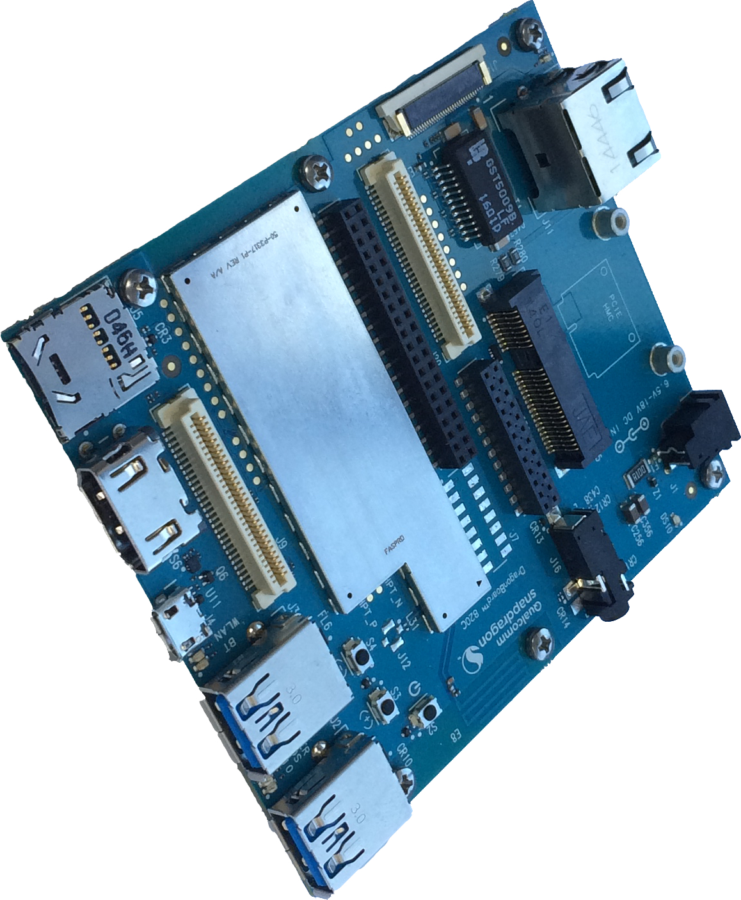

**Powered by:**



**Contents**

1 Introduction 5

2 Key features 6

Board overview 8

3 What’s in the Box 9

4 Getting started 10

Prerequisites 10

Starting the board for the first time 10

5 DragonBoard Overview 11

System Block diagram 11

Processor 11

Memory 11

MicroSD 11

WiFi/BT/RF 11

Display Interface 12

HDMI 12

MIPI-DSI 12

Camera Interfaces 12

USB Ports 12

USB-Host ports 12

USB-Device port 12

Audio 13

BT Audio 13

HDMI Audio 13

Input DC-power 13

Measurements 13

Buttons 13

UART 13

System and user LEDs 13

Expansion Connector 14

Additional Functionality 14

GPS 14

Ethernet Connector 14

Mini PCIE connector 14

Inertial Sensors 14

6 Low speed Expansion connector 15

UART {0/1} 16

I2C {0/1} 16

GPIO {A-L} 16

SPI 0 16

PCM/I2S 16

Power and Reset 16

Power Supplies 17

7 High speed expansion connectors 18

Primary high speed expansion connector 18

MIPI DSI 0 19

MIPI CSI {0/1} 19

I2C {2/3} 19

HSIC 19

Reserved 19

SD/SPI 20

Clocks 20

USB 20

Secondary High Speed Connector 20

Feature information 21

MIPI DSI 1 22

I2C {CCI_0,CCI _1, SSC_2} 22

SPI {SSC_1} 22

SPI {SSC_UART_1, _2, _3} 22

TSIF – Transport Stream Interface 22

Other signals on Secondary High Speed Connector 22

8 Analog Expansion Connectors 23

16-pin Analog Connector 23

Earpiece 23

Microphones 23

Headset 23

9 24 pin Audio Expansion 24

Analog Microphones 24

Digital Microphones 24

Line Out 24

10 Power management 25

DC Power Input 25

Power Source Selection 25

Power Consumption 25

Power Sequencing 25

Power Measurements 25

DC-In measurement 25

PMIC Power-In measurement (VPH_PWR measurement) 26

11 Buttons and status LED’s 27

Buttons 27

Volume up 27

Volume down 27

Power Button 27

Entering Fastboot 27

Hard Reset 27

Holding power and volume down buttons for 15 seconds will force a hard reset of the DragonBoard 820c. 27

LEDs 27

User LED 1-4 28

Bluetooth status 28

WiFi status 28

12 Boot configuration 29

13 Mechanical specification 30

Additional interfaces 31

14 License Agreement 32

EVALUATION BOARD LICENSE AGREEMENT 32

WARRANTY 32

INDEMNIFICATION 33

RECYCLING 33

# Introduction

Acronyms and abbreviation definitions

| Acronym /  Abbreviation | Definition |
| --- | --- |
| BOM | Bill Of Materials |
| BT | Blue Tooth |
| CLK | Clock |
| CPU | Central Processing Unit |
| CS | Chip Select |
| CSI | Camera Serial Interface |
| DSI | Display Serial Interface |
| EMC | Electro-Magnetic Compatibility |
| EMI | Electro-Magnetic Interference |
| EN | ENable |
| ESD | Electro-Static Discharge |
| GND | GrouND |
| GPIO | General Purpose I/O |
| GPS | Global Positioning System |
| HDMI | High Definition Multimedia Interface |
| I2C | Inter-Integrated Circuit |
| I2S | Inter-IC Sound |
| INT | INTerrupt |
| ISP | Image Sensor Processor |
| LDO | Low Drop-Out |
| LRM | Linear Resonant Actuator |
| LTE | Long-Term Evolution |
| MDP | Mobile Display Port |
| MI2S | Mobile Inter-IC Sound |
| MIC | MICrophone |
|  |  |
| MIPI | Mobile Industry Processor Interface |
| MPP | Multi-Purpose Pin |
| NFC | Near Field Communication |
| PCB | Printed Circuit Board |
| PCIE | Peripheral Component Interconnect Express |
| PWM | Pulse-Width Modulation |
| RF | Radio Frequency |
| RX | Receive |
| SCL | Serial CLock |
| SDA | Serial DAta |
| SDC | Secure Digital Interface |
| SOM | System On Module |
| SPI | Serial Peripheral Interface |
| SSC | Snapdragon™ Sensor Core |
| TX | Transmit |
| UART | Universal Asynchronous Receiver/Transmitter |
| UIM | User Interface Module |
| USB | Universal Serial Bus |
| WLAN | Wireless Local Area Network |

# Key features

The DragonBoard 820c (‘820c’) board is a 96Boards compliant community board based on Qualcomm® Snapdragon™ 820 processor.

The following table lists its key features:

|  |  |
| --- | --- |
| Processor | Qualcomm Snapdragon 820  Quad-core Qualcomm® Kryo™at up to 2.15GHz per core  64-Bit capable  Qualcomm® Adreno™ 530 624MHz GPU for PC-class graphics with support for  advanced APIs, including OpenGL ES 3.1+, OpenCL, DirectX, and content security |
| Memory/  Storage | 3GB LPDDR4 1866MHz  32GB UFS 2.0  SD 3.0 (UHS-I) |
| Video | 4K UltraHD@30fps video playback and capture with H.264 (AVC) and H.265 (HEVC) |
| Camera Support | Integrated Dual ISP with support for 3 image sensors up to 28MP |
| Audio | PCM/AAC+/MP3/WMA, ECNS, Audio+ post-processing (optional) |
| Connectivity | WLAN 2x2 802.11 b/g/n/ac 2.4 and 5GHz with on-board dual band WLAN antennas  Bluetooth v4.1 with on-board antenna  GbE Ethernet connection  One USB 2.0 micro B (device mode only)  Two USB 3.0 (host mode only)  GPS with On-board GPS antenna |
| I/O Interfaces | MINI PCIe  One 40-pin Low Speed (LS) expansion connector  • UARTx2, SPI, I2S, I2C x2, GPIO x12, DC power  Primary 60-pin High Speed (HS) expansion connector  • 4L-MIPI DSI, USB, I2C x2, 2L+4L-MIPI CSI, SPI  Secondary 60-pin High Speed (HS) expansion connector  • 4L-MIPI DSI, DC power, 1.8V supply, I2C, Camera Flash control, Display control, 2 x GPIO, Sensor core SPI, 3 x UART, I2C  Audio support including:  • Stereo Speaker and Mono microphone via 3.5mm headset jack  •24 pin audio expansion connector  •3.3V supply, 2 x analog line in, 4 x analog line out, speaker amp control, 2 x digital microphone links supporting a total of 4 microphones  ***NOTE: Qualcomm Snapdragon, Kryo, Adreno and Hexagon are all products of Qualcomm Technologies, Inc.***  •16 pin audio expansion connector  •stereo headset/line out, speaker and analog line in  Camera connector based upon 96boards camera interface addendum. 30 pin connector ZIF connector with 4L-CSI, DC power, 5V and 3.3V supply, camera control signals, I2C.  The 820c board can be made compatible with Arduino compatible shield using an add-on mezzanine. Go to:  <http://www.96boards.org/product/sensors-mezzanine/>  For more information about compatible mezzanine cards |
| External Storage | Micro SD card slot |
| User Interface | Switches  • Power/Reset  • Volume Up  • Volume down  6 LED indicators  • 4 - user controllable  • 2 - for radios (BT and WLAN activity) |
| Sensors | 6-axis IMU containing accelerometer and gyroscope  3-axis magnetometer |
| OS-support | Linux Debian |
| Power,  Mechanical and  Environmental | Input voltage: +6.5V to +18V  Dimensions: 100mm by 85mm meeting 96Boards™ Consumer Edition ’extended’ dimensions specifications.  Operating Temp: 0°C to +40°C  RoHS and Reach compliant |

## Board overview

|  |  |
| --- | --- |
| 1. | (J11) Ethernet Connector |
| 2. | (J1) Power Jack |
| 3. | (J14) Camera Connector |
| 4. | (J15) MINI PCIE Connector |
| 5. | (J16) 3.5mm Headset Jack |
| 6. | (J20) Secondary High Speed Connector |
| 7. | (J21) 24 pin Audio Connector |
| 8. | (J8) Low Speed Connector |
| 9. | (DS10) Power up indicator |
| 10. | GPS Antenna |
| 11. | Shield Compartment containing APQ8096/LPDDR4, PM8996, WGR7640 |
| 12. | (S2) Power Button  (S3-4) Vol+/Vol- Buttons |
| 13. | (J5) microSD connector |
| 14. | (J9) Primary High Speed Connector |
| 15. | HDMI Connector |
| 16. | (J4) Micro USB Type B Connector |
| 17. | Bluetooth/WLAN LED’s |
| 18. | (J3) USB Host1 connector |
| 19. | User LEDs 1-4 |
| 20. | (J2) USB Host2 connector |
| 21 | WLAN/BT Antenna |
| 22. | WLAN Antenna2 |
| 23. | (S1) Boot Switches |

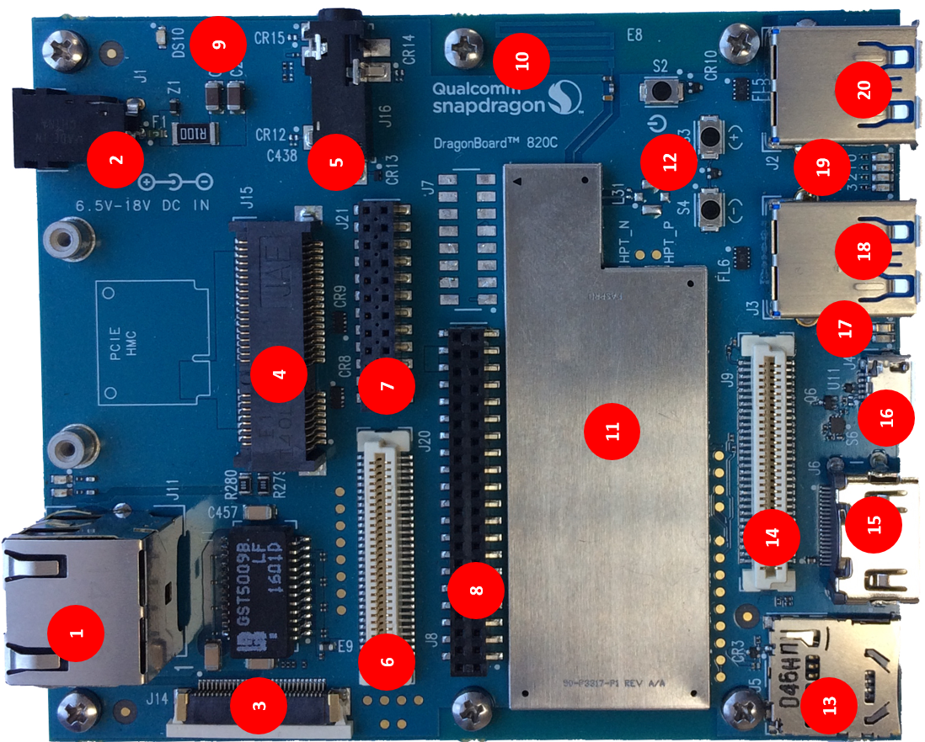

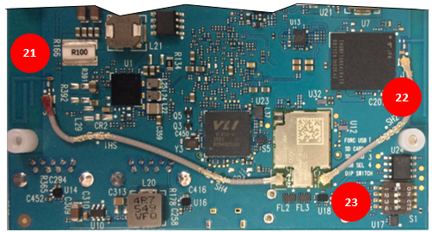

# What’s in the Box

The box contains one DragonBoard 820c development board.

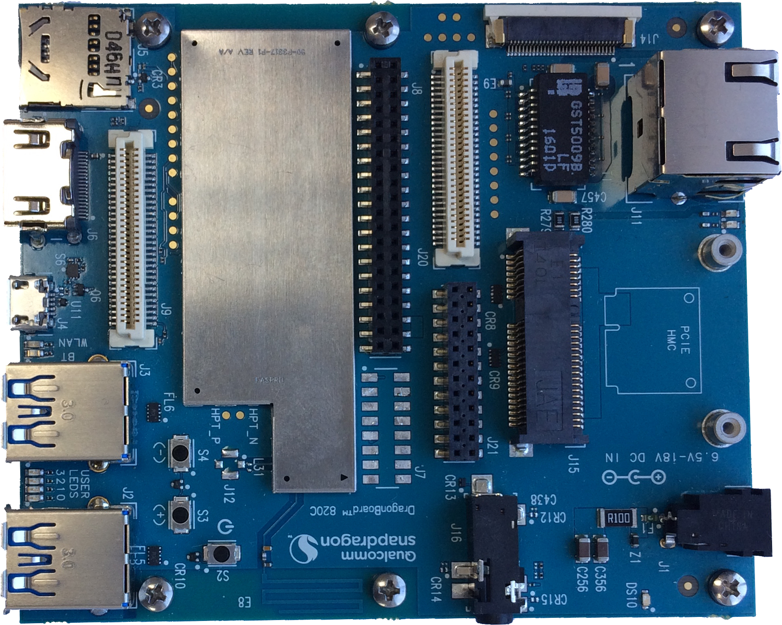

# Getting started

## Prerequisites

Before you power up your DragonBoard 820c for the first time you will need the following:

* DragonBoard 820c board
* A 96Boards compliant power supply (sold separately by Arrow) Input voltage range of 6.5-18V, recommended input current of 2A minimum.
* A HDMI or DVI LCD Monitor that supports a minimum resolution of 1080P/30Hz
* HDMI-HDMI cable or HDMI-DVI cable to connect the board to the Monitor
* A computer keyboard with USB interface
* A computer mouse with USB interface

## Starting the board for the first time

To start the board, follow these simple steps:

1. Connect the HDMI cable to the 820c HDMI connector (marked J6) and to the LCD Monitor.
2. Connect the mouse and keyboard to the 820C USB connectors marked J2 and. (It doesn’t matter which order you connect them in. You can also connect via an external USB Hub.)
3. ***Ensure that the boot switches S1 are set to ‘0000’, all in Off position.***
4. Connect the power supply to power connector J1.

step 5. Plug the power supply into a power outlet.

The board will start the booting process, and you should see Linux boot up. The ’power up’ blue LED ‘DS10’ should illuminate.

Please note that the first boot takes 3-4 minutes due to first time initialization. Subsequent boot times should be faster in the range of 1-2 minutes.

# DragonBoard Overview

## System Block diagram



## Processor

The Snapdragon 820 (APQ8096) processor has a quad 64-bit Qualcomm® Kryo™ CPU , supporting LPDDR4 SDRAM interface, Hexagon 680 DSP, 28 MP camera input support, Adreno 530 GPU, 4K Ultra HD video encode/decode, gpsOneGen 8C with GLONASS, Bluetooth 4.1, OpenGL ES 3.1+, DirectX, OpenCL, Renderscript Compute, FlexRender support.

## Memory

The DragonBoard 820c uses a package on package (PoP) LPDDR4 RAM configuration and discrete UFS 2.0 flash memory

* The LPDDR4 interfaces directly to the APQ8096 built-in LPDDR controller. The maximum DDR clock is 1866 Mhz.
* The UFS flash memory interfaces with APQ8096 over a dedicated UFS/M-PHY bus supporting the UFS 2.0 specification.

## MicroSD

The 96Boards specification calls for a microSD socket to be present on the board.

The DragonBoard 820c SD slot (J5) signals are routed directly to the APQ8096 SDC2 interface. The slot is a push-push type with a dedicated support for card detect signal (many SD slots do not have a dedicated CD pins, they use DATA3 state as the card detected signal). The DragonBoard 820c uses APQ GPIO_38 as the SD_CARD_DET_N.

## WiFi/BT/RF

The 96Boards specifications calls for a WiFi (minimally 802.11g/n) and Bluetooth 4.1 (Bluetooth Low Energy)

The DragonBoard 820c uses Qualcomm QCA6174A module solution that integrates two wireless connectivity technologies into a single device, the interfaces are:

* WLAN compliant with IEEE 802.11 b/g/n/ac specifications, exceeding 96Boards minimal requirements for WiFi.
* Bluetooth compliant with the BT specifications version 4.1 (BR/EDT + BLE), meeting the 96Boards requirements for BT

## Display Interface

### HDMI

The 96Boards specification calls for an HDMI port to be on the board. The DragonBoard 820c provides native support for an HDMI interface. It supports a resolution up to 4K Ultra HD resolution at 60Hz.

### MIPI-DSI

The 96Boards specification calls for a MIPI-DSI implementation via the High Speed Expansion Connector.

The 820c implements a four-lane MIPI_DSI on the primary high speed connector interface which meets the 96boards MIPI-DSI high speed connector requirement. An additional four-lane MIPI_DSI bus is implemented on the secondary high speed connector. More information about this implementation can be found in chapter7 High speed expansion connector.

## Camera Interfaces

The 96Boards specification calls for two camera interfaces.

The DragonBoard 820c implements three camera interfaces.

* 4 lane CSI camera on camera connector J14
* 4 lane CSI camera on primary high speed connector J9
* 2 lane CSI camera on primary high speed connector J9

The DragonBoard 820c includes an on-board 4-lane MIPI-CSI camera bus, routed to a 30 pin ZIF connector.

More information about this implementation can be found in chapter 6 High speed expansion connector.

## USB Ports

### USB-Host ports

The 96Boards specification calls for three USB host ports.

The DragonBoard 820c supports 3 USB Host ports as follows.

Port 1 of the USB HUB is routed to J2, a Type ‘A’ USB Host 3.0 (Superspeed) connector. A current limited controller (U14) sets the Power Current limit to 1.0A. This port is named HOST1 in the board schematic.

Port 2 of the USB HUB is routed to J3, a Type ‘A’ USB Host 3.0 (Superspeed) connector. A current limited controller (U16) sets the Power Current limit to 1.0A. This port is named HOST2 in the board schematic.

Port 3 of the USB HUB is routed to the High Speed Expansion connector. No current limited controller is implemented on the board for this channel.

### USB-Device port

The 96Boards specification calls for a USB port to be implemented as an OTG port or a device port.

The DragonBoard 820c implements a USB device port. The port is located at J4, a MicroUSB type B. If an application requires the use of the device port, USB HUB_SEL switch (S1-4) shall be set to ‘0’ which is the default setting. Setting USB_SEL switch S1-4 to ‘ON’ will put the 820C into Emergency Download mode (EDL) which will render the device unusable for all other functionality.

### Audio

The 96Boards specifications calls for a minimum of single channel audio through two interfaces, BT and HDMI/MHL/DisplayPort

The DragonBoard 820c meets this requirement with HDMI support and has additional audio channels, including support for headset jack. More information about these additional channels can be found in sections 7 and 8.

Note that MHL is not supported.

### BT Audio

The BT 4.1 implementation on the DragonBoard 820c is via a MAC in the APQ8096 and an external modem, contained in the WIFI/BT module.

### HDMI Audio

HDMI audio is carried over the HDMI signals to the HDMI connector (J6).

## Input DC-power

The 96Boards specification calls for power to be provided to the board in one of the following ways:

* 8V to 18V input voltage power supplied from a dedicated DC jack
* 8V to 18V input voltage power supplied from the SYS_DCIN pins on the Low Speed Expansion Connector
* A USB Type C port at 5V

Please see section 9 for detailed information on DragonBoard 820c implementation of DC Power. Note that the DragonBoard 820c does not support USB Type C.

## Measurements

The 96Boards specification calls for support for measuring power consumptions of the board.

Please see the power measurement section for detailed information on DragonBoard 820c power measurement implementation.

## Buttons

The 96Boards specification calls for the presence of two buttons, a Power on/sleep button and a Reset button.

This board meets these requirements. Please see section 10 for detailed information on the buttons of the DragonBoard 820c.

## UART

The 96Boards specification calls for support for one SoC UART and an optional second UART both to be routed to the Low Speed Expansion Connector.

The DragonBoard 820c routes 2 UARTs to the low speed connector and additionally routes 3 SSC UART TX/RX lines to the secondary high speed connector J20.

## System and user LEDs

The 96Boards specifications calls for six LEDs to be implemented on the board. The specification defines the LEDs color and mechanical location on the board.

**Two activity LEDs:**

• WiFi activity LED – DragonBoard 820c drives this Yellow LED via MPP_2, an IO from the PMIC.

• BT activity LED – DragonBoard 820c drives this Blue LED via MPP_4 an IO from the PMIC.

**Four User-LEDs:**

The four user LEDs are surface mount Green in 0603 size located next to the two USB type A connector and labeled ‘USER LEDS 3 2 1 0’. The DragonBoard 820c drives three LEDs from the red, green and blue LED drive from power management IC PMI8996. The fourth User LEDs is driven by the PMI8996 via PM MPP2.

**Power indicator LED:**

A blue LED is included to indicate the presence of input power to the DragonBoard 820c.

## Expansion Connector

The 96Boards specification calls for two Expansion Connectors, a Low Speed and a High Speed.

The DragonBoard 820c meets this requirement for low speed and exceeds it by having two high speed connectors, please review section 6.0 for detailed information regarding the Low Speed Expansion Connector and section 7.0 for detailed information regarding the High Speed Expansion Connectors.

## Additional Functionality

The 96Boards specifications allows for additional functionality provided that all mandatory functionality is available and there is no impact on the physical footprint specifications including height and do not prevent the use of the 96Boards CE low speed and high speed expansion facilities

The DragonBoard 820c implements additional functions, which are listed in the following sub-chapters.

### GPS

The GPS implementation is based on Qualcomm WGR7640 GNSS RF receiver (U5) supporting GPS, GLONASS and COMPASS. The APQ8096 communicates directly with the WGR7640.

### Ethernet Connector

Gigabit Ethernet is supported by Qualcomm AR8151 controller and uses an RJ45 as the physical interface.

### Mini PCIE connector

The DragonBoard 820c includes a mini PCIE (PCI express) connector. This enables integration of HW peripherals which are compliant to the PCIE mini specification.

### Inertial Sensors

The DragonBoard 820c includes the following inertial sensors

* 6-axis accelerometer/gyroscope: ST Micro LSM6DS3
* 3-axis magnetometer: ST Micro LIS3MDL

# Low speed Expansion connector

The following tables show the Low Speed Expansion Connector pin out:

|  |  |  |  |  |
| --- | --- | --- | --- | --- |
| PIN | 96Boards Signals | | 820c Signals | Note |
| 1 | GND | | GND |  |
| 3 | UART0_CTS | | UART0_CTS_N (APQ GPIO_51) |  |
| 5 | UART0_TxD | | UART0_TX (APQ GPIO_49) |  |
| 7 | UART0_RxD | | UART0_RX (APQ GPIO_50) |  |
| 9 | UART0_RTS | | UART0_RTS_N (APQ GPIO_52) |  |
| 11 | UART1_TxD | | UART1_TX (APQ GPIO_4) |  |
| 13 | UART1_RxD | | UART1_RX (APQ GPIO_5) |  |
| 15 | I2C0_SCL | | I2C0_SCL (APQ GPIO_48) |  |
| 17 | I2C0_SDA | | I2C0_SDA (APQ GPIO_47) |  |
| 19 | I2C1_SCL | | I2C1_SCL (APQ GPIO_7) |  |
| 21 | I2C1_SDA | | I2C1_SDA (APQ GPIO_6) |  |
| 23 | GPIO-A | | LS_EXP_GPIO_A (APQ GPIO_80) |  |
| 25 | GPIO-C | | LS_EXP_GPIO_C (APQ GPIO_124) |  |
| 27 | GPIO-E | | LS_EXP_GPIO_E (APQ GPIO_62) |  |
| 29 | GPIO-G | | LS_EXP_GPIO_G (APQ GPIO_10) |  |
| 31 | GPIO-I | | LS_EXP_GPIO_I (APQ GPIO_25) |  |
| 33 | GPIO-K | | LS_EXP_GPIO_K (APQ GPIO_23) |  |
| 35 | +1V8 | | VREG_S4_1P8 |  |
| 37 | +5V | | VREG_5P0 |  |
| 39 | GND | | GND |  |
|  |  | |  |  |
| PIN | 96Boards Signals | 820c Signals | | Note |
| 2 | GND | GND | |  |
| 4 | PWR_BTN_N | PHONE_ON_N | |  |
| 6 | RST_BTN_N | PM_RESIN_N | |  |
| 8 | SPI0_SCLK | SPI0_CLK (APQ GPIO_3) | |  |
| 10 | SPI0_DIN | SPI0_MISO (APQ GPIO_1) | |  |
| 12 | SPI0_CS | SPI0_CS_N (APQ GPIO_2) | |  |
| 14 | SPI0_DOUT | SPI0_MOSI (APQ GPIO_0) | |  |
| 16 | PCM_FS | PCM_FS (APQ GPIO_59) | |  |
| 18 | PCM_CLK | PCM_CLK (APQ GPIO_58) | |  |
| 20 | PCM_DO | PCM_DO (APQ GPIO_60) | |  |
| 22 | PCM_DI | PCM_DI (APQ GPIO61) | |  |
| 24 | GPIO-B | GPIO_B (APQ GPIO_29) | |  |
| 26 | GPIO-D | GPIO_D (APQ GPIO_24) | |  |
| 28 | GPIO-F | GPIO_F (PM_GPIO_5) | | ***Used GPIO from PMIC*** |
| 30 | GPIO-H | GPIO_H (APQ GPIO_8) | |  |
| 32 | GPIO-J | GPIO_J (APQ GPIO_26) | |  |
| 34 | GPIO-L | GPIO_L (APQ GPIO_133) | |  |
| 36 | SYS_DCIN | SYS_DCIN | |  |
| 38 | SYC_DCIN | SYS_DCIN | |  |
| 40 | GND | GND | |  |
|  |  |  | |  |

## UART {0/1}

The 96Boards specifications calls for a 4-wire UART implementation, UART0 and an optional second 2-wire UART, UART1 on the Low Speed Expansion Connector.

The DragonBoard 820c implements UART0 as a 4-wire UART that connects directly to the APQ8096 SoC. These signals are driven at 1.8V.

The DragonBoard820c implements UART1 as a 2-wire UART that connects directly to the APQ8096 SoC. These signals are driven at 1.8V.

## I2C {0/1}

The 96Boards specification calls for two I2C interfaces to be implemented on the Low Speed Expansion Connector.

The DragonBoard 820c implements both interfaces, I2C0 and I2C1 that connects directly to the APQ8096 SoC. A 2.2K resistor is provided as pull-up for each of the I2C lines per the I2C specifications, these pull-ups are connected to the 1.8V voltage rail.

## GPIO {A-L}

The 96Boards specifications calls for 12 GPIO lines to be implemented on the Low Speed Expansion Connector. Some of these GPIOs may support alternate functions for DSI/CSI control

The DragonBoard 820c implements this requirement. 11 GPIOs are routed to the APQ8096 SoC and one GPIO is connected to the on-board PMIC. All are 1.8V signals. Reference the connector pinout table for details regarding GPIO assignments

* Note: GPIO C - Connects to GPIO_125 of APQ8096 SoC, can serves as TS_INT0 supporting the 96Boards requirements to create a wake-up event for the SoC.

## SPI 0

The 96Boards specification calls for one SPI bus master to be provided on the Low Speed Expansion Connector.

The DragonBoard 820c implements a full SPI master with 4 wires, CLK, CS, MOSI and MISO all connect directly to the APQ8096 SoC. These signals are driven at 1.8V.

## PCM/I2S

The 96Boards specification calls for one PCM/I2S bus to be provided on the Low Speed Expansion Connector. The CLK, FS and DO signals are required while the DI is optional.

The DragonBoard 820c implements a PCM/I2S with 4 wires, CLK, FS, D0 and DI. The I2S signals are connected directly to the APQ8096 SoC. These signals are driven at 1.8V.

## Power and Reset

The 96Boards specification calls for a signal on the Low Speed Expansion Connector that can power on/off the board and a signal that serves as a board reset signal.

The DragonBoard820c routes the PWR_BTN_N (named PHONE_ON_N on 820c schematic) signal to the KYPDPWR_N pin of the PMI8996 PMIC. This signal is driven by S2 as well, the on-board power on push-button switch. Please note that the push button only provides an On/Sleep function and not OFF functionality.

A mezzanine implementation of this signals should not drive it with any voltage, the only allowed operation is to force it to GND to start the board from a sleep mode. A board shutdown will occur when this signal is held to ground for more than 15 seconds.

The DragonBoard 820c routes the RST_BTN_N (named PM_RESIN_N on 820c schematic) signal to the RESIN_N pin of the PMI8996 PMIC. This signal is driven by S4, the on-board reset switch. This signals is a dual purpose, any press lasting less than 10 seconds serves as Volume Down or Zoom out, a press longer than 10 seconds will reset the board.

## Power Supplies

The 96Boards specification calls for three power rails to be present on the Low Speed Expansion Connector:

* +1.8V : Max of 100mA
* +5V : Able to provide a minimum of 5W of power (1A).
* SYS_DCIN : 9-18V input with enough current to support all the board functions or the output DCIN from on-board DC Connector able to provide a minimum of 7W of power.

The DragonBoard 820c supports these requirements as follows:

+1.8V : Driven by PMIC LDO VREG_S4, which can provide 100mA.

+5V : Driven by the 5A 5.0V DC to DC converter (U10). This buck switcher powers both USB limit current devices (each at 1.0A max). The remaining capacity provides a max current of 3A to the Low Speed Expansion Connector, for a total of 8.2W which meets the 96Boards requirements.

SYS_DCIN: Can serves as the board’s main power source or can receive power from the board. It supports a minimum of 7W.

# High speed expansion connectors

## Primary high speed expansion connector

The following table shows the High Speed Expansion Connector pin out:

|  |  |  |  |
| --- | --- | --- | --- |
| **PIN** | **96Boards Signals** | **820c Signals** | **Note** |
| 1 | SD_DAT0/SPI1_DOUT | SPI1_MOSI (APQ GPIO_85) | ***This is a SPI implementation. not an SD interface*** |
| 3 | SD_DAT1 | N.C. |
| 5 | SD_DAT2 | N.C. |
| 7 | SD_DAT3/SPI1_CS | SPI1_CS_N (APQ GPIO_87) |
| 9 | SD_SCLK/SPI1_SCLK | SPI1_CLK (APQ GPIO_88) |
| 11 | SD_CMD/SPI1_DIN | SPI1_MISO (APQ GPIO_86) |
| 13 | GND | GND |  |
| 15 | CLK0/CSI0_MCLK | CSI0_MCLK (APQ GPIO_13) |  |
| 17 | CLK1/CSI1_MCLK | CSI1_MCLK (APQ GPIO_15) |  |
| 19 | GND | GND |  |
| 21 | DSI_CLK+ | MIPI_DSI0_CLK_P_EXP_CONN |  |
| 23 | DSI_CLK- | MIPI_DSI0_CLK_M_EXP_CONN |  |
| 25 | GND | GND |  |
| 27 | DSI_D0+ | MIPI_DSI0_DATA0_P_EXP_CONN |  |
| 29 | DSI_D0- | MIPI_DSI0_DATA0_M_EXP_CONN |  |
| 31 | GND | GND |  |
| 33 | DSI_D1+ | MIPI_DSI0_DATA1_P_EXP_CONN |  |
| 35 | DSI_D1- | MIPI_DSI0_DATA1_M_EXP_CONN |  |
| 37 | GND | GND |  |
| 39 | DSI_D2+ | MIPI_DSI0_DATA2_P_EXP_CONN |  |
| 41 | DSI_D2- | MIPI_DSI0_DATA2_M_EXP_CONN |  |
| 43 | GND | GND |  |
| 45 | DSI_D3+ | MIPI_DSI0_DATA3_P_EXP_CONN |  |
| 47 | DSI_D3- | MIPI_DSI0_DATA3_M_EXP_CONN |  |
| 49 | GND | GND |  |
| 51 | USB_D+ | USB_HS_D_P_EXP |  |
| 53 | USB_D- | USB_HS_D_M_EXP |  |
| 55 | GND | GND |  |
| 57 | HSIC_STR | N.C. | ***No HSIC implementation*** |
| 59 | HSIC_DATA | N.C. |
|  |  |  |  |
| **PIN** | **96Boards Signals** | **820c Signals** | **Note** |
| 2 | CSI0_C+ | MIPI_CSI0_CLK_P |  |
| 4 | CSI0_C- | MIPI_CSI0_CLK_M |  |
| 6 | GND | GND |  |
| 8 | CSI0_D0+ | MIPI_CSI0_DATA0_P |  |
| 10 | CSI0_D0- | MIPI_CSI0_DATA0_M |  |
| 12 | GND | GND |  |
| 14 | CSI0_D1+ | MIPI_CSI0_DATA1_P |  |
| 16 | CCSI0_D1- | MIPI_CSI0_DATA1_M |  |
| 18 | GND | GND |  |
| 20 | CSI0_D2+ | MIPI_CSI0_DATA2_P |  |
| 22 | CSI0_D2- | MIPI_CSI0_DATA2_M |  |
| 24 | GND | GND |  |
| 26 | CSI0_D3+ | MIPI_CSI0_DATA3_P |  |
| 28 | CSI0_D3- | MIPI_CSI0_DATA3_M |  |
| 30 | GND | GND |  |
| 32 | I2C2_SCL | I2C2_SCL (APQ GPIO_18) |  |
| 34 | I2C2_SCL | I2C2_SDA (APQ GPIO_17) |  |
| 36 | I2C3_SDA | I2C3_SCL (APQ GPIO_56) |  |
| 38 | I2C3_SDA | I2C3_SDA (APQ GPIO_55) |  |
| 40 | GND | GND |  |
| 42 | CSI1_D0+ | MIPI_CSI2_DATA0_P |  |
| 44 | CSI1_D0- | MIPI_CSI2_DATA0_M |  |
| 46 | GND | GND |  |
| 48 | CSI1_D1+ | MIPI_CSI2_DATA1_P |  |
| 50 | CSI1_D1- | MIPI_CSI2_DATA1_M |  |
| 52 | GND | GND |  |
| 54 | CSI1_C+ | MIPI_CSI2_CLK_P |  |
| 56 | CSI1_C- | MIPI_CSI2_CLK_M |  |
| 58 | GND | GND |  |
| 60 | RESERVED | VREG_S4_1P8 |  |
|  |  |  |  |

### MIPI DSI 0

The 96Boards specification calls for a MIPI-DSI to be present on the High Speed Expansion Connector. A minimum of one lane is required and up to four lanes can be accommodated on the connector.

The DragonBoard 820c implementation supports a full four lane MIPI-DSI interface that is routed to the Primary High Speed Expansion Connector.

### MIPI CSI {0/1}

The 96Boards specification calls for two MIPI-CSI interfaces to be present on the High Speed Expansion Connector. Both interfaces are optional. CSI0 interface can be up to four lanes while CSI1 is up to two lanes.

The current DragonBoard 820c implementation supports a full four lane MIPI-CSI interface on CSI0 and two lanes of MIPI-CSI on CSI2. All MIPI-CSI signals are routed directly to/from the APQ8096.

### I2C {2/3}

The 96Boards specification calls for two I2C interfaces to be present on the High Speed Expansion Connector. Both interfaces are optional unless a MIPI-CSI interface has been implemented. Then an I2C interface shall be implemented.

The current DragonBoard820c implementation supports two MIPI-CSI interfaces and therefore must support two I2C interfaces.

For MIPI-CSI0 the companion I2C2 is routed directly from the APQ8096. For MIPI-CSI2, the companion I2C is I2C3.

### HSIC

The 96Boards specification calls for an optional MIPI-HSIC interface to be present on the High Speed Expansion Connector.

The DragonBoard 820c implementation doesn’t support this optional requirement.

### Reserved

The 96Boards specification calls for a 100K pull-up to 1.8V to be connected to pin 60 of the High Speed Expansion Connector.

The DragonBoard 820c utilizes a 100K pull-up (R147) on pin 60.

### SD/SPI

The 96Boards specification calls for an SD interface or a SPI port to be part of the High Speed Expansion Connector.

The DragonBoard 820c implements a full SPI master with 4 wires (96Boards SPI Configuration), CLK, CS, MOSI and MISO all connect directly to the APQ8096 SoC. These signals are driven at 1.8V.

### Clocks

The 96Boards specification calls for one or two programmable clock interfaces to be provided on the High Speed Expansion Connector. These clocks may have a secondary function of being CSI0_MCLK and CSI1_MCLK. If these clocks can’t be supported by the SoC than an alternative GPIO or No-Connect is allowed by the specifications.

The DragonBoard 820c implements two CSI clocks, CAM_MCLK0 via APQ GPIO_13 for CSI0 and CAM_MCLK2via APQ GPIO_15 for CSI1. These signals are driven at 1.8V.

### USB

The 96Boards specification calls for a USB Data line interface to be present on the High Speed Expansion Connector.

The DragonBoard 820c implements this requirement by routing USB channel 3 from the USB HUB to the High Speed Expansion Connector.

## Secondary High Speed Connector

Given the extensive I/O available on the APQ8096, a second high speed connector has been added to support additional interfaces for development and integration.

Currently, the SW supporting these features is pre-commercial and many features are not implemented. Refer to the notes section in the table regarding SW support.

While there are functions assigned for primary usages such as I2C bus, SPI bus, TSIF, etc., most pins can be repurposed as GPIOs if needed and their GPIO # assignments are included for reference. The following table shows the Secondary High Speed Expansion Connector pin out:

|  |  |  |
| --- | --- | --- |
| **PIN** | **820c Signals** | **Note** |
| 1 | FLASH_STROBE_TRIGGER (APQ GPIO_22) | Configured for GPIO use only |
| 3 | MI2S_MCLK (APQ GPIO_57) | Configured for GPIO use only |
| 5 | FLASH_STROBE_EN (APQ GPIO_21) | Configured for GPIO use only |
| 7 | SSC_SPI1_CS_N (APQ SSC8) | Currently not configured in SW |
| 9 | SSC_SPI1_CLK (APQ SSC9) | Currently not configured in SW |
| 11 | BL1_EN (PMGPIO_6) |  |
| 13 | GND |  |
| 15 | SSC_SPI_1_MOSI (APQ SSC10) | Currently not configured in SW |
| 17 | SSC_SPI_1_MISO (APQ SSC11) | Currently not configured in SW |
| 19 | GND |  |
| 21 | MIPI_DSI1_CLK_P_EXP_CONN |  |
| 23 | MIPI_DSI1_CLK_M_EXP_CONN |  |
| 25 | GND |  |
| 27 | MIPI_DSI1_DATA0_P |  |
| 29 | MIPI_DSI1_DATA0_M |  |
| 31 | GND |  |
| 33 | MIPI_DSI1_DATA1_P |  |
| 35 | MIPI_DSI1_DATA1_M |  |
| 37 | GND |  |
| 39 | MIPI_DSI1_DATA2 |  |
| 41 | MIPI_DSI1_DATA2 |  |
| 43 | GND |  |
| 45 | MIPI_DSI1_DATA3_P |  |
| 47 | MIPI_DSI1_DATA3_M |  |
| 49 | GND |  |
| 51 | LCD1_RESET_N (APQ-GPIO101) | Currently not configured in SW |
| 53 | BL1_PWM (PM-GPIO4) |  |
| 55 | MDP_VSYNC_S (APQ-GPIO11) | Currently not configured in SW |
| 57 | DC_IN | 500mA max input on these pins |
| 59 | DC_IN |
|  |  |  |
| **PIN** | **820c Signals** | **Note** |
| 2 | APQ-GPIO121 | Currently not configured in SW |
| 4 | APQ-GPIO30 | Configured as Cam/Stdby |
| 6 | GND |  |
| 8 | SSC_UART_3_TX (APQ SSC6) | Currently not configured in SW |
| 10 | SSC_UART_3_RX (APQ SSC7) | Currently not configured in SW |
| 12 | GND |  |
| 14 | SSC_UART_1_TX (APQ SSC12) | Currently not configured in SW |
| 16 | SSC_UART_1_RX (APQ SSC13) | Currently not configured in SW |
| 18 | GND |  |
| 20 | SSC_UART_2_TX (APQ SSC14) | Currently not configured in SW |
| 22 | SSC_UART_2_RX (APQ SSC15) | Currently not configured in SW |
| 24 | GND |  |
| 26 | SSC_I2C_2_SDA (APQ SSC4) | Currently not configured in SW |
| 28 | SSC_I2C_2_SCL (APQ SSC5) | Currently not configured in SW |
| 30 | GND |  |
| 32 | CCI_I2C_SCL0 (APQ GPIO_18) |  |
| 34 | CCI_I2C_SDA0 (APQ GPIO_17) |  |
| 36 | CCI_I2C_SCL1 (APQ GPIO_20) |  |
| 38 | CCI_I2C_SDA1 (APQ GPIO_19) |  |
| 40 | GND |  |
| 42 | APQ GPIO_89) |  |
| 44 | APQ GPIO_91 |  |
| 46 | APQ GPIO_90 |  |
| 48 | APQ GPIO_39 |  |
| 50 | GND |  |
| 52 | APQ GPIO_93 |  |
| 54 | (APQ GPIO_95 |  |
| 56 | APQ GPIO_94 |  |
| 58 | APQ GPIO_96 |  |
| 60 | VREG_S4A_1P8 |  |

### Feature information

Please refer to table notes column regarding which features are currently supported in SW.

### MIPI DSI 1

The secondary high speed connector supports a 4-lane MIPI-DSI bus.

Additional signals on the secondary high speed connector which can be used for display integration include:

* BL1_EN (APQ-GPIO6) for backlight control.
* LCD1_RESET_N (APQ-GPIO101). Display control line.
* BL1_PWM (PM-GPIO4). For backlight level control.
* MDP_VSYNC_S(APQ-GPIO11). Display timing control

These signals can also be used as generic GPIOs

### I2C {CCI_0,CCI _1, SSC_2}

The secondary high speed connector supports three I2C busses.

* CCI_I2C_0
* CCI_I2C_1
* SSC_I2C_2

These busses can also be used as generic GPIOs

### SPI {SSC_1}

The secondary high speed connector supports one SPI bus- SSC_SPI_1.

This bus can also be used as generic GPIOs

### SPI {SSC_UART_1, _2, _3}

The secondary high speed connector supports three UART busses- SSC_UART_1, _2 and _3

These busses can also be used as generic GPIOs.

### TSIF – Transport Stream Interface

XXXXXX

### Other signals on Secondary High Speed Connector

Other signals include

* 1.8V supply
* DC_IN 6.5V to 18V with up to 500mA maximum per pin on two pins
* APQ-GPIO122
* APQ-GPIO30
* FLASH_STROBE_TRIGGER (APQ-GPIO22)
* MI2S_MCLK (APQ-GPIO57)
* FLASH_STROBE_EN (APQ-GPIO21)

# Analog Expansion Connectors

## 16-pin Analog Connector

Unless otherwise noted, these signals interface to the WCD9335 codec (U3).

|  |  |  |  |
| --- | --- | --- | --- |
| PIN | Function | Connect to | Note |
| 1 | CDC_EAR_M |  |  |
| 2 | CDC_EAR_P |  |  |
| 3 | VPH_PWR | 3.8V from U20 buck switcher |  |
| 4 | GND |  |  |
| 5 | CDC_IN1_M |  |  |
| 6 | CDC_IN4_P |  | Mic 4 can be used for ANC headset |
| 7 | CDC_IN1_P |  |  |
| 8 | CDC_HPH_R |  |  |
| 9 | HPH_REF |  |  |
| 10 | CDC_HPH_L |  |  |
| 11 | MBHC_HS_DET_L |  | Mechanical insertion detection |
| 12 | MIC_BIAS2 |  |  |
| 13 | CDC_IN4_M |  | Mic 4 can be used for ANC headset |
| 14 | CDC_IN3_M |  | Mic 3 can be used for ANC headset |
| 15 | N.C. |  |  |
| 16 | CDC_IN3_P |  | Mic 3 can be used for ANC headset |

### Earpiece

The earpiece signals are routed from the WCD9335 codec, the two signals are:

* CDC_EAR_M
* CDC_EAR_P

### Microphones

The 3 analog microphones are connected to the WCD9335 codec, the three mics are:

* MIC1
* MIC3 Can be used as part of an active noise canceling (ANC) system
* MIC4 Can be used as part of an active noise canceling (ANC) system
* MIC_BIAS2 Ground reference

### Headset

The headset signals are rounded from the WCD9335 codec, one signal is routed from the connector to the CODEC, the singles are:

* CDC_HPH_R - Headphone PA right channel output
* CDC_HPH_L - Headphone PA left channel output
* HPH_REF - Headphone PA ground sensing
* MBHC_HS_DET_L - Headset detection

# 24 pin Audio Expansion

Unless otherwise noted, these signals interface to the WCD9335 codec (U3).

|  |  |  |  |
| --- | --- | --- | --- |
| PIN | Function | Connect to | Note |
| 1 | CDC_IN5_M |  |  |
| 2 | CDC_IN6_M |  |  |
| 3 | CDC_IN5_P |  |  |
| 4 | CDC_IN6_P |  |  |
| 5 | MIC_BIAS3 |  |  |
| 6 | MIC_BIAS1 |  |  |
| 7 | GND |  |  |
| 8 | SPKR_AMP_EN1 | PMI8996 (U1) |  |
| 9 | CDC_SWR_CLK |  |  |
| 10 | CDC_SWR_DATA |  |  |
| 11 | SPKR_AMP_EN2 | PMI8996 (U1) |  |
| 12 | GND |  |  |
| 13 | CDC_DMIC_CLK1 |  |  |
| 14 | CDC_DMIC_CLK2 |  |  |
| 15 | CDC_DMIC_DATA1 |  |  |
| 16 | CDC_DMIC_DATA2 |  |  |
| 17 | CDC_LINE_OUT2_M |  |  |
| 18 | CDC_LINE_OUT2_P |  |  |
| 19 | CDC_LINE_OUT1_M |  |  |
| 20 | CDC_LINE_OUT1_P |  |  |
| 21 | CDC_LINE_REF |  |  |
| 22 | VREG_3P3 | 3.3V from U20 buck switcher |  |
| 23 | CDC_LINE_OUT4 |  |  |
| 24 | CDC_LINE_OUT3 |  |  |

### Analog Microphones

The 24 pin audio expansion connector supports 2 additional analog microphone inputs:

* MIC5
* MIC6
* MIC_BIAS1, _BIAS3: Ground reference

### Digital Microphones

The 24 pin audio expansion connector supports 2 additional analog microphone inputs:

* DMIC_1
* DMIC_2

### Line Out

The 24 pin audio expansion connector supports 4 line outputs:

Line_Out1, Line_Out2: Differential drivenLine_Out3, Line_out4: Single ended with CDC_Line_Ref to use as a reference ground.

* Audio Amplifier interface. The 24 pin audio expansion connector supports the following interface and control of audio amplifiers:Soundwire (CDC_SWR_CLK, SWR_DATA): Used and audio interface to Qualcomm WSA8810 or 8815 speaker amplifiers.
* Amplifier control via SPKR_AMP_EN1, _EN2

# Power management

The 96Boards specification defines how power arrives to the board and few supplies that the board needs to provide. The on board power requirement for each 96Boards implementation depends on the SoC and the set of peripherals that are specific to that implementation.

The DragonBoard 820c uses three buck regulators, U20, U10 and U21. U20 takes the power in to the board and generates 3.8V at 6A. This voltage serves as the power in voltage to the on-board PMI8996 IC. U10 takes the power in to the board and generates 5V at 5A. This voltage feeds the USB HOST power limit switches, provides power to the Low Speed Expansion port and other HW peripheral interfaces. U21 takes the power in to the board and generates 3.3V at 5A. 3.3V is used to power HW peripherals as well as to expansion connectors.

## DC Power Input

The 96Boards specification calls for a power to be provided to the board in one of the following ways:

* An 8V to 18V power from a dedicated DC jack.
  + The DragonBoard 820c supports this requirement through the use of J1, ‘SYS_DCIN’ power connector.    
    **Please note:** the SYS_DCIN can be as low as 6.5V on the DragonBoard820c.
* Note that the DragonBoard 820c operates from a ~24W supply such as a 12V/2A supply. An 8V to 18V power from the SYS_DCIN pins on the Low Speed Expansion Connector.   
  **Please note:** the SYS_DCIN can be as low as 6.5V on the DragonBoard820c.  
  The DragonBoard 820c supports incoming power through this connector.
* A USB Type C port at 5V.   
  **Please note:** **The DragonBoard 820c does not implement a USB Type C port and** ***therefore cannot be powered over USB.***

## Power Source Selection

Following the information in section 9.1, the DragonBoard 820c has only two sources for board incoming power. The 96Boards specification calls for only one power source to be applied to the board at any given time. Following this requirement, ***the user of the DragonBoard 820c should never apply power to the board from J1 and the Low Speed Expansion connector at the same time***. There is no active or passive mechanism on the DragonBoard 820c to prioritize one source over the other.

## Power Consumption

TBD

## Power Sequencing

Upon applying power to the DragonBoard 820c (either one of the two sources), both buck regulators will be enabled and will start regulating their target voltages. When the output of U20 is on, it will power the on-board PMIC, the PMI8996. PMI8996 generates VPH_PWR which supplies the PM8996. The sequencing of all power rails is set within the PMIC configuration scheme during the production of this part. The user has no access to alter, modify or change the PMIC power up sequencing.

## Power Measurements

The 96Boards specification calls for a minimum of one current sense resistor to be placed on the board permitting a basic power measurement functions.

The DragonBoard 820c implements two different power measurements.

### DC-In measurement

A 0.01ohm resistor R167 is placed inline to the SYS_DCIN power line coming from J1 (please note that this power in measurement only works for SYS_DCIN from J1, it will not measure SYS_DCIN applied from the Low Speed Expansion Connector). The two sides of this resistor are connector to pins J10-1 and J10-2. Placing a probe over these jumper pins will provide a voltage measurement of the voltage drop across the resistor. Dividing this measurement by 0.01 will give you the amount of the current flowing into the board.

### PMIC Power-In measurement (VPH_PWR measurement)

A 0.01ohm resistor R166 is placed inline to the SYS_PWR on the 3.8V supply on the output of U20. The two sides of this resistor are connector to pins J22-1 and J22-2. Placing a probe over these jumper pins will provide a voltage measurement of the voltage drop across the resistor. Dividing this measurement by 0.01 will give you the amount of the current flowing into the board.

# Buttons and status LED’s

## Buttons

### Volume up

The Volume UP button (S3) is used to control the audio volume of the DragonBoard 820c.

### Volume down

The Volume Down button (S4) is used to control the audio volume of the DragonBoard 820c.

### Power Button

The push-button S2 serves as the power-on/off/sleep button. Upon applying power to the board, the boot process will start. Once the board is powered on and booted up:

Sleep/suspend

* You can put the device to sleep by pressing this button momentarily.
* You can wake the device from sleep by pressing this button momentarily.

Power Off/On

Option 1: Long press/hold

* While the device is awake, pressing and holding the power button S2 for longer than 15 seconds will result in the device powering off.
* Once powered off, pressing and holding the power button S2 for longer than 15 seconds will result in the device powering on.

Option 2: Short press/hold

* While the device is awake, pressing and holding the power button S2 for ~2-3 seconds seconds will result in the user interface displaying the ‘power off’ notifier:



* Using a mouse, clicking on this notifier will cause the 820c to power off.
* Once powered off, pressing and holding the power button S2 for longer than 2-3 seconds will result in the device powering on.

### Entering Fastboot

Holding down power and volume down buttons at power oup of the DragonBoard 820c will force the device to enter fastboot mode.

### Hard Reset

## Holding power and volume down buttons for 15 seconds will force a hard reset of the DragonBoard 820c.

## LEDs

There are two status LEDs and four User LEDs on the DragonBoard 820c. The Status LEDs report the status of the Bluetooth and Wi-Fi devices onboard. The user LEDs are driven by the SoC directly.

### User LED 1-4

The four user LEDs are surface mount Green LEDs, 0603 size, located next to the two USB type A connector and labeled ‘USER LEDS 3 2 1 0’.

### Bluetooth status

The BT LED on the DragonBoard 820c is located next to the USBOTG connector; this LED reflects the status of the Bluetooth device.

### WiFi status

The WIFI LED on the DragonBoard 820c is located beside the BT LED, this LED reflects the status of the Wi-Fi device.

**Power Indicator LED**

The Dragonboard 820c contains a power indicato0 to notify the user that power is applied.

# Boot configuration

There is a 4 switch DipSwitch marked S1 located at the bottom side of the DragonBoard 820c. For normal operation, all four switches need to be set to the ‘off’ position.

Switch 1, ‘USB BOOT’, when set to ‘on’ position, will force boot over USB connection with a PC. This is only required for UFS boot image upgrade. Please review the proper OS User Guide for more information on this process.

Switch 2, SD BOOT’, when set to ‘on’ position, will force the SD, J5, to serve as the boot source for the DragonBoard 820c. You can use uSD as the main boot source or it can serve as a method for UFS boot image upgrade. Please review the proper OS User Guide for more information on this process.

Switch 3, ‘SW Download Target Memory’, when set to ‘on’ position, will force SW download/flashing to the SD card, J5 When set to ‘off’ position, SW download will route to the UFS memory.

Switch 4, ‘HUB_SEL’, when set to ‘on’ position, selects USB Port 0 for EDL download mode. Please review the proper OS User Guide for more information on this process.

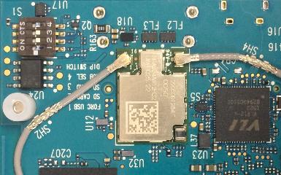

# Mechanical specification

## Additional interfaces

The DragonBoard 820c includes interfaces which are in addition to the base 96boards CE Extended specification. These include

* J21: 24-pin audio expansion connector
* J20: Secondary High Speed Connector
* J14: Camera connector
* J16: Headset Jack
* J11: Ethernet connector

Locations of these connectors are noted on the following drawing

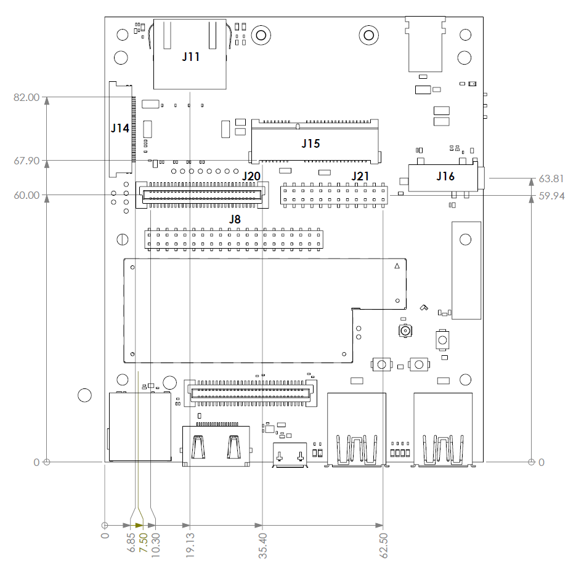

# License Agreement

**ARROW ELECTRONICS**

## EVALUATION BOARD LICENSE AGREEMENT

**By using this evaluation board or kit (together with all related software, firmware, components, and documentation provided by Arrow, “Evaluation Board”), You (“You”) are agreeing to be bound by the terms and conditions of this Evaluation Board License Agreement (“Agreement”). Do not use the Evaluation Board until You have read and agreed to this Agreement. Your use of the Evaluation Board constitutes Your acceptance of this Agreement.**

PURPOSE

The purpose of this evaluation board is solely intended for evaluation purposes. Any use of the Board beyond these purposes is on your own risk. Furthermore, according the applicable law, the offering Arrow entity explicitly does not warrant, guarantee or provide any remedies to you with regard to the board.

LICENSE

Arrow grants You a non-exclusive, limited right to use the enclosed Evaluation Board offering limited features only for Your evaluation and testing purposes in a research and development setting. Usage in a live environment is prohibited**.** The Evaluation Board shall not be, in any case, directly or indirectly assembled as a part in any production of Yours as it is solely developed to serve evaluation purposes and has no direct function and is not a finished product.

EVALUATION BOARD STATUS

The Evaluation Board offers limited features allowing You only to evaluate and test purposes. The Evaluation Board is not intended for consumer or household use. You are not authorized to use the Evaluation Board in any production system, and it may not be offered for sale or lease, or sold, leased or otherwise distributed for commercial purposes.

OWNERSHIP AND COPYRIGHT

Title to the Evaluation Board remains with Arrow and/or its licensors. This Agreement does not involve any transfer of intellectual property rights (“IPR) for evaluation board. You may not remove any copyright or other proprietary rights notices without prior written authorization from Arrow or it licensors.

RESTRICTIONS AND WARNINGS

Before You handle or use the Evaluation Board, You shall comply with all such warnings and other instructions and employ reasonable safety precautions in using the Evaluation Board. Failure to do so may result in death, personal injury, or property damage.

You shall not use the Evaluation Board in any safety critical or functional safety testing, including but not limited to testing of life supporting, military or nuclear applications. Arrow expressly disclaims any responsibility for such usage which shall be made at Your sole risk.

## WARRANTY

**Arrow warrants that it has the right to provide the evaluation board to you. This warranty is provided by Arrow in lieu of all other warranties, written or oral, statutory, express or implied, including any warranty as to merchantability, non-infringement, fitness for any particular purpose, or uninterrupted or error-free operation, all of which are expressly disclaimed. The evaluation board is provided “as is” without any other rights or warranties, directly or indirectly**.

**You warrant to Arrow that the evaluation board is used only by electronics experts who understand the dangers of handling and using such items, you assume all responsibility and liability for any improper or unsafe handling or use of the evaluation board by you, your employees, affiliates, contractors, and designees**.

LIMITATION OF LIABILITIES

**In no event shall Arrow be liable to you, whether in contract, tort (including negligence), strict liability, or any other legal theory, for any direct, indirect, special, consequential, incidental, punitive, or exemplary damages with respect to any matters relating to this agreement. In no event shall Arrow’s liability arising out of this agreement in the aggregate exceed the amount paid by you under this agreement for the purchase of the evaluation board.**

## INDEMNIFICATION

You shall, at Your expense, defend Arrow and its Affiliates and Licensors against a claim or action brought by a third party for infringement or misappropriation of any patent, copyright, trade secret or other intellectual property right of a third party to the extent resulting from (1) Your combination of the Evaluation Board with any other component, system, software, or firmware, (2) Your modification of the Evaluation Board, or (3) Your use of the Evaluation Board in a manner not permitted under this Agreement. You shall indemnify Arrow and its Affiliates and Licensors against and pay any resulting costs and damages finally awarded against Arrow and its Affiliates and Licensors or agreed to in any settlement, provided that You have sole control of the defense and settlement of the claim or action, and Arrow cooperates in the defense and furnishes all related evidence under its control at Your expense. Arrow will be entitled to participate in the defense of such claim or action and to employ counsel at its own expense.

## RECYCLING

The Evaluation Board is not to be disposed as an urban waste. At the end of its life cycle, differentiated waste collection must be followed, as stated in the directive 2002/96/EC. In all the countries belonging to the European Union (EU Dir. 2002/96/EC) and those following differentiated recycling, the Evaluation Board is subject to differentiated recycling at the end of its life cycle, therefore: It is forbidden to dispose the Evaluation Board as an undifferentiated waste or with other domestic wastes. Consult the local authorities for more information on the proper disposal channels. An incorrect Evaluation Board disposal may cause damage to the environment and is punishable by the law.